# F. Y. B. Tech Academic Year 2021-22

**Subject:** Basics of Electrical and Electronics Engineering **Trimester:II**

**Name: Shreerang Mhatre Division: 11**

**Roll No: 111056 Batch : K3**

# Experiment No: 8

**Name of the Experiment**: Finding Resonant Frequency of series R-L-C circuit

**Performed on: 11/02/2022**

**Submitted on: 13/02/2022**

# Aim : Finding Resonant Frequency of series R-L-C circuit

**Objective**

To understand the resonance in series R-L-C circuit and to find out resonant frequency of given R-L-C circuit

**Components and equipment required**

|  |  |
| --- | --- |
| **Components** | **Specifications** |
| Signal Generator | Audio frequency range |
| AC Ammeter | 0-1 A |
| R-L-C circuit board |  |

**Theory**

In the series R-L-C circuit, when inductive reactance equals the capacitive reactance circuit is called as series resonance circuit. Circuit behaves like a resistive circuit and the resulting current is in phase with the applied voltage. Circuit power factor is unity. At resonance, the equivalent impedance of the circuit consists of only resistive components due to cancelling out the reactive components. At this condition circuit draws the maximum current shown in Fig.4 due to minimum impedance of the circuit as shown in Fig.3. As is directly proportional to frequency and is inversely proportional to frequency, we can obtain the resonance of any R-L-C circuit by varying its frequency.

The frequency, at which this condition occurs, is known as resonance frequency of that circuit. The magnitude of the resonating frequency can be calculated using eq.(1)

(1)

During series resonance, voltage magnification is observed. Voltage across the capacitor or inductor is multiple times the supply voltage. This can be observed using the term Q factor or Quality factor of the circuit which is given by eq. (2)

(2)

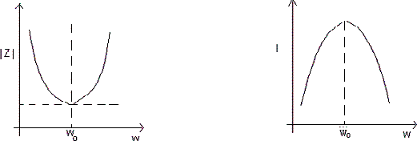

Fig.2: Impedance vs frequency Fig.3: Current vs frequency

**Procedure**

1. Connect the circuit as shown in Fig.1
2. Give 10V peak to peak sinusoidal input at 100 Hz from the signal generator.
3. Change the frequency from 100 Hz To 1800 Hz and obtain the maximum current in the circuit. Note down this reading as resonant frequency.
4. Adjust frequencies for five equally spaced readings above and below the resonant frequency and note down corresponding current values.

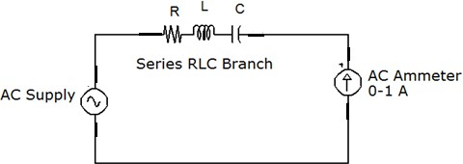

**Fig. 4: Series R-L-C Circuit**

**Observations**

1. **Components used in the series circuit:**
   1. 15 mH ii) 2 µF iii)30 Ω O4 Batch
   2. 10 mH ii) 1 µF iii)30 Ω O3 Batch
2. **Observation Table : Resistance = 30 Ω**

|  |  |  |  |
| --- | --- | --- | --- |
| **Sr. No** | **Frequency (Hz)** | **Voltage (V) accros R**  **(CRO**  **Readings)** | **Current (mA)**  **= Voltage V / 30 Ω** |
| **1** | **100 Hz** | 2.56 | 0.8 |
| **2** | **200 Hz** | 5.7 | 0.9 |
| **3** | **400 Hz** | 14.4 | 0.5 |
| **4** | **600 Hz** | 2.48 | 0.8 |
| **5** | **800 Hz** | 5.8 | 0.9 |
| **6** | **900Hz** | 7.00 | 0.23 |
| **7** | **950Hz** | 7.00 | 0.24 |
| **8** | **1000 Hz** | 6.2 | 0.2 |
| **9** | **1200 Hz** | 4.00 | 0.13 |
| **10** | **1400 Hz** | 2.49 | 0.83 |
| **11** | **1600 Hz** | 2.00 | 0.06 |
| **12** | **1800 Hz** | 1.6 | 0.05 |

**Graph and Calculations**

1. Plot graph of Current vs. Frequency
2. Mark resonant frequency from the graph.
3. Calculate resonant frequency using eq.(1).

**Result**

|  |  |
| --- | --- |
|  | **Resonance Frequency (Hz)** |
| **Practical Value** | 1600 |
| **Theoretical Value** | 1592 |

**Conclusion**

Hence, we have found the value of resonant frequency and concluded that the practical values from our simulation and theoretical value from our calculations for the same are in close confirmation.

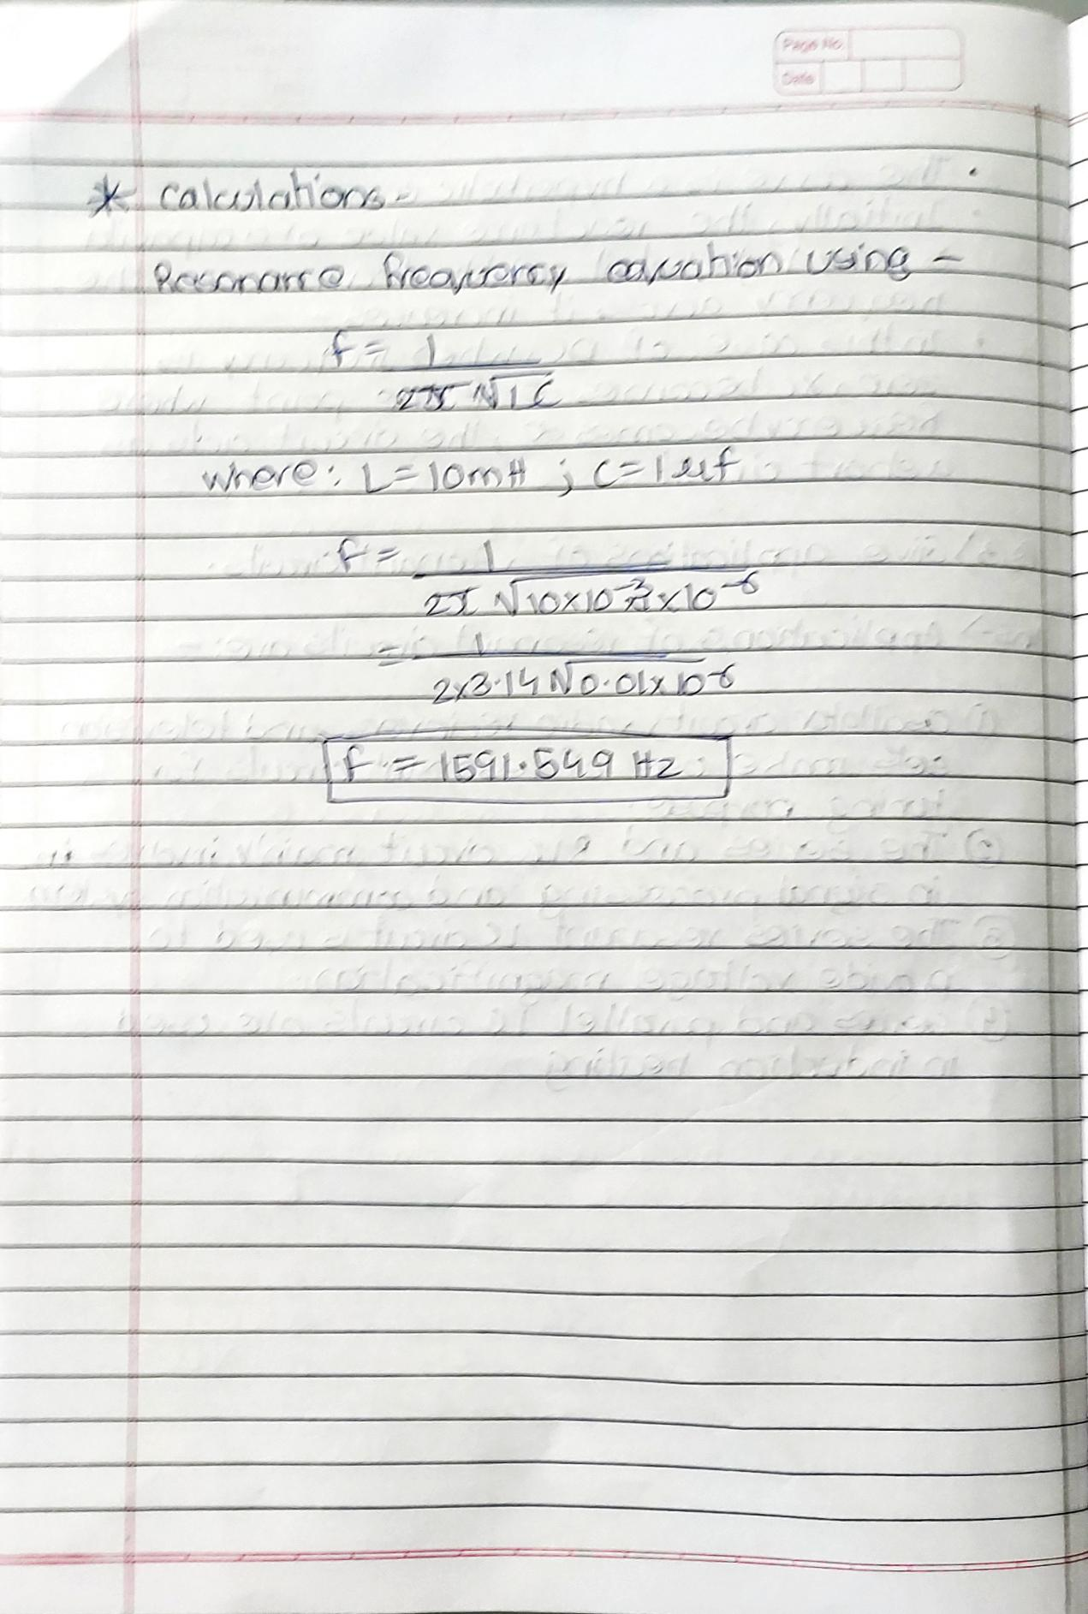

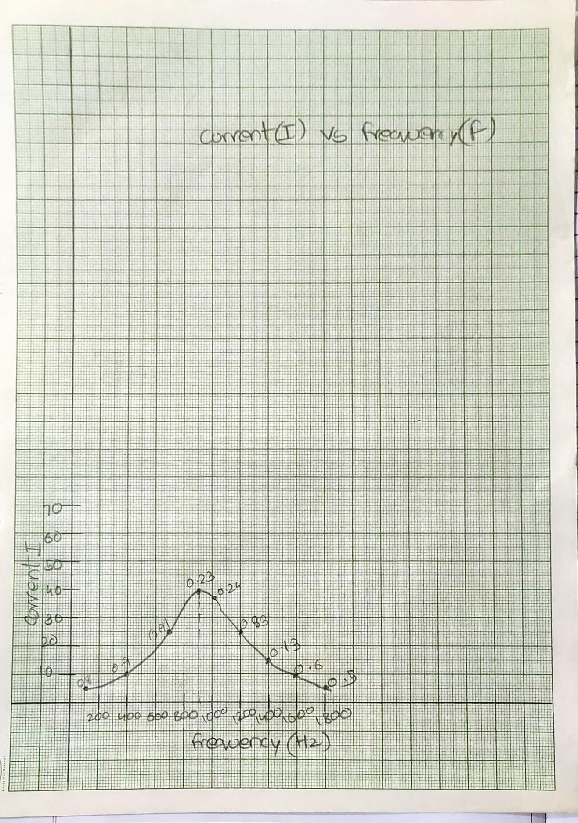

**RLC Circuit:**

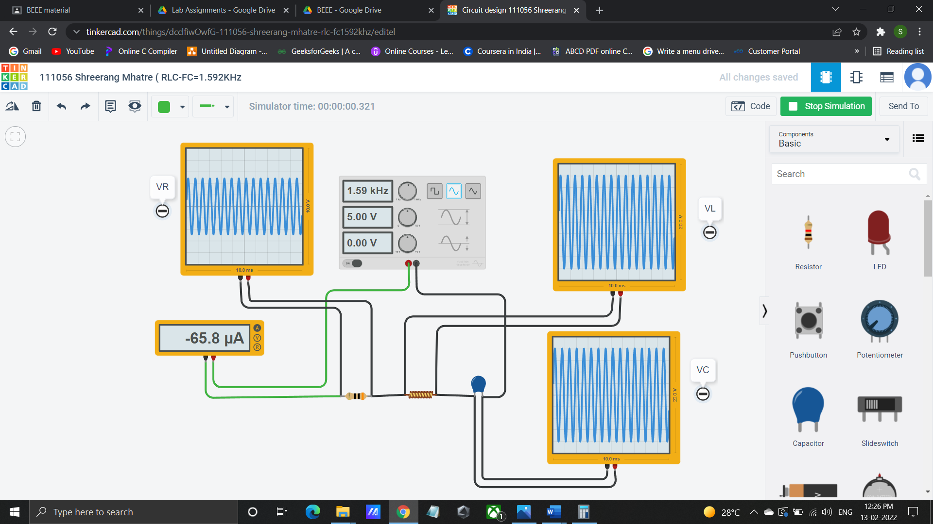

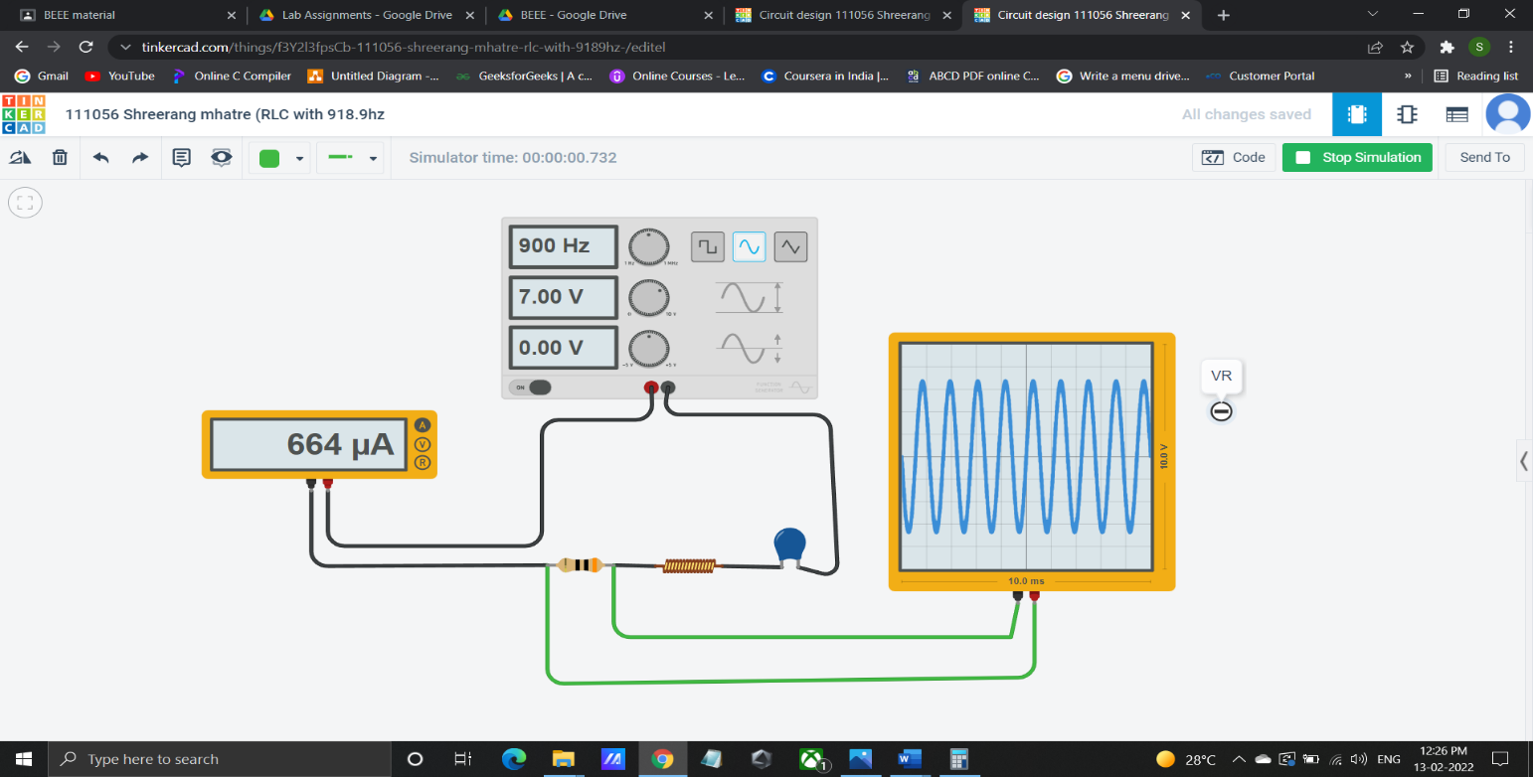

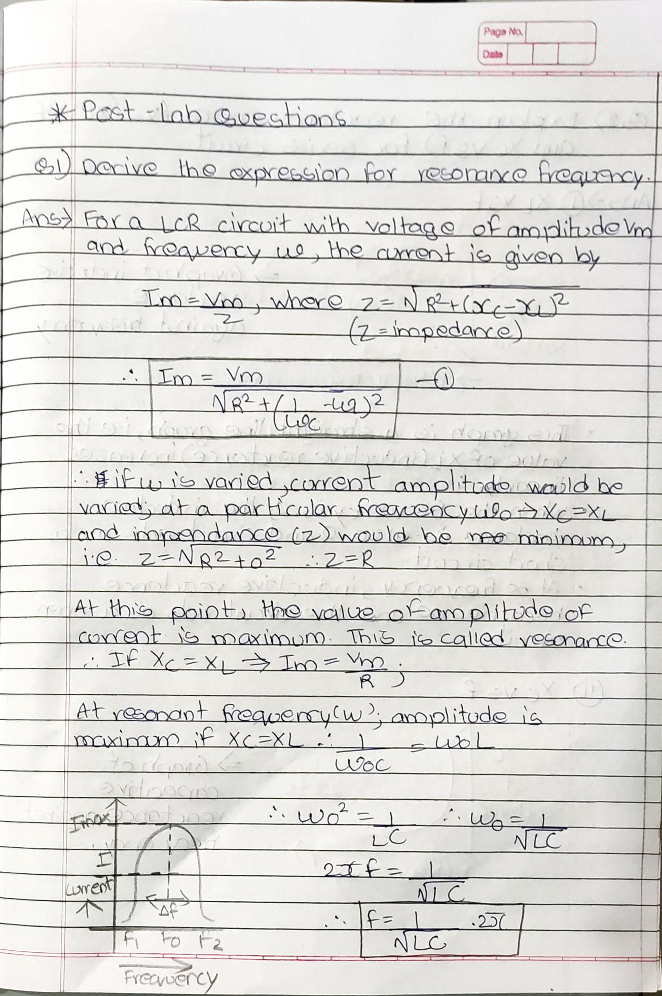

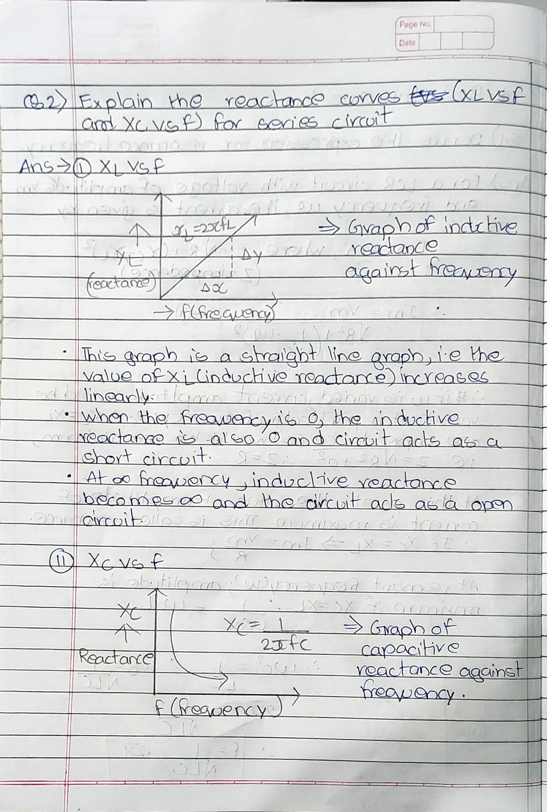

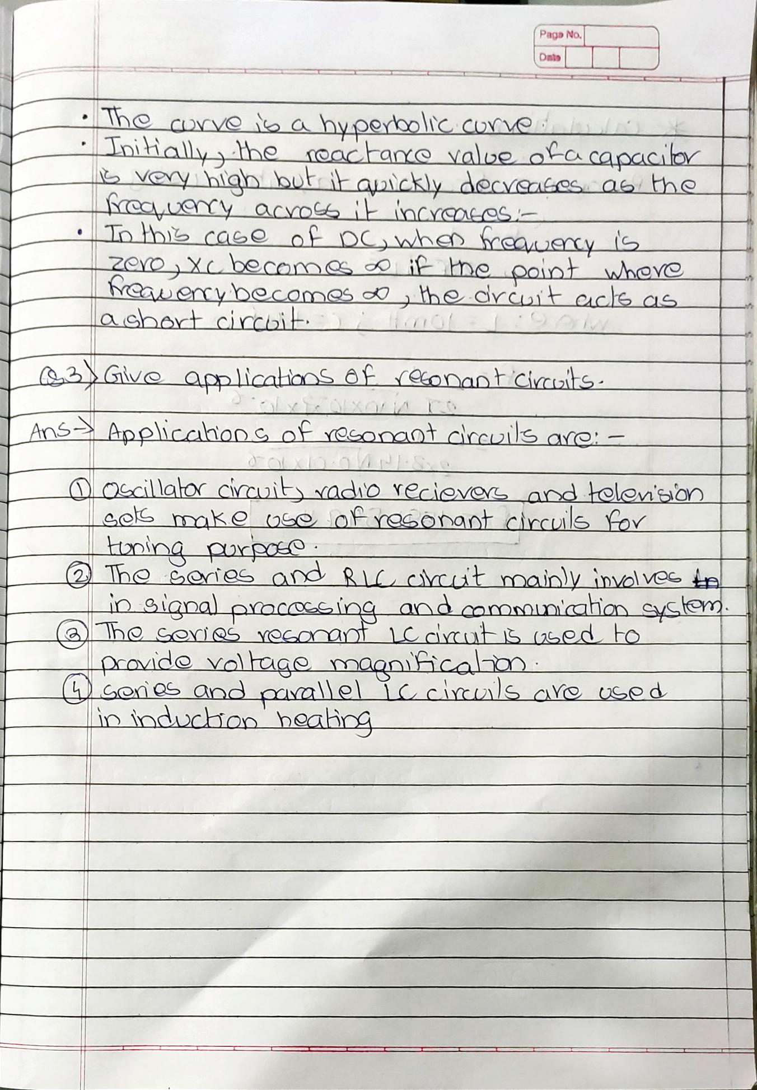

**Post-Lab Questions**

* 1. Derive the expression for resonance frequency.
  2. Explain the reactance curves ( vs and vs ) for series circuit.
  3. Give applications of resonant circuits.

**Note: Students are instructed to do all necessary calculations and answer the questions on separate sheets and attach them.**

**Applications of the Resonant RLC Circuits**

* Oscillator **circuit**, radio receivers, and television sets are used for the tuning purpose.
* The series and **RLC circuit** mainly involves in signal processing and communication system.
* The Series resonant **LC circuit** is used to provide voltage magnification.